**Assignment-6**

Course: SC-374

Computational and Numerical Methods

Instructor: Prof. Arnab Kumar

Made by:

Yatin Patel – 201601454

Rutvik Kothari – 201601417

# **Problem: 1**

♦ **Statement:**

Carry out the Lagrange linear interpolation between (1, 1) and (4, 2). Plot your interpolation function together with $y=x^{\frac{1}{2}}$ for comparison.

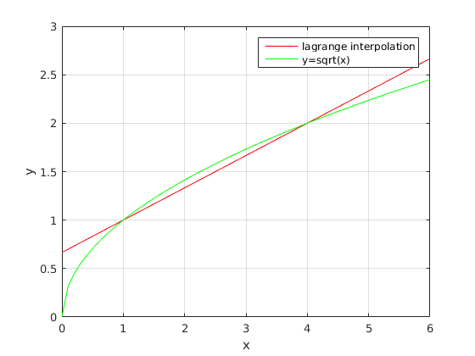

# **Problem: 2**

♦ **Statement:**

Carry out a Lagrange linear interpolation for (0.82, 2.270500) and (0.83, 2.293319). Extend your study with a Lagrange quadratic polynomial using (0.84, 2.316367). Compare your polynomials with the function $=e^{x}$, plotting all of them on same graph.

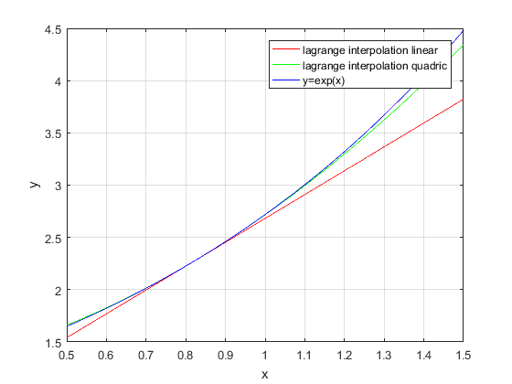

# **Problem: 3**

♦ **Statement:**

Construct a quadratic Lagrange polynomial using the points (0, −1), (1, −1) and (2, 7). Plot your result. Extend this entire exercise with Newton’s divided-difference quadratic polynomial and compare the two methods.

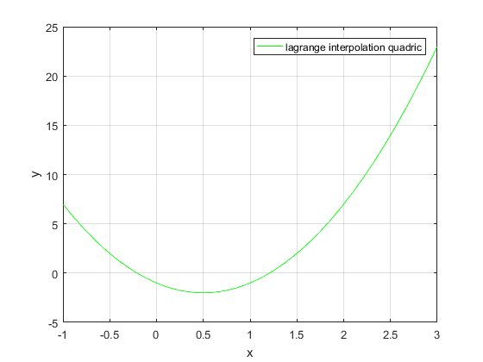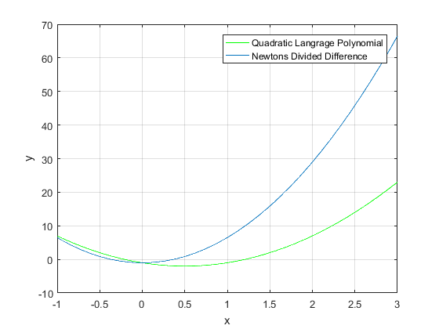

# **Problem: 4**

♦ **Statement:**

With the data in provided in table

1. Produce Lagrange polynomials of the linear, quadratic and cubic orders

With increasing values of x.

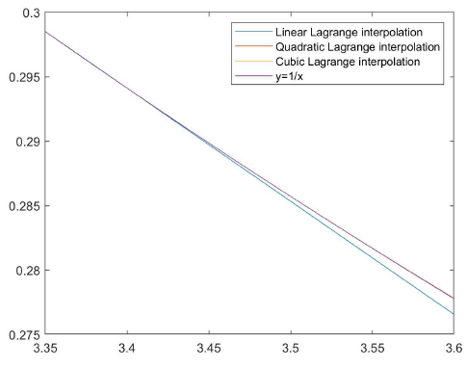

1. Produce Newton’s divided-difference polynomials of the linear, quadratic and cubic orders with increase value of x .

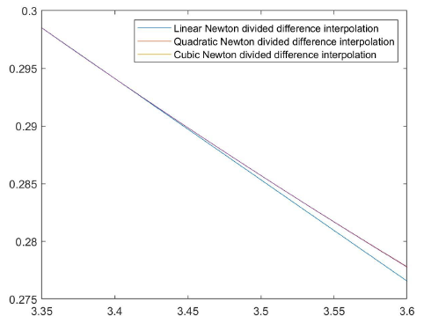

1. Plot the result of both methods on the same graph and compare them with the function $y =\frac{1}{x}$. Also comment on respective computational advantage of the two methods.

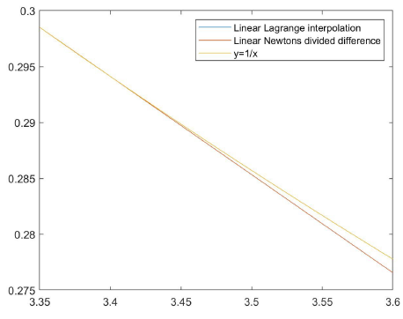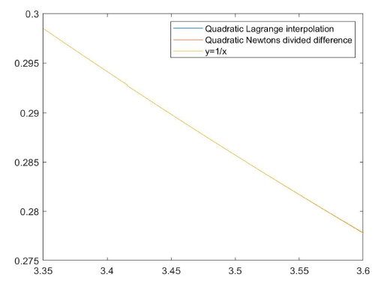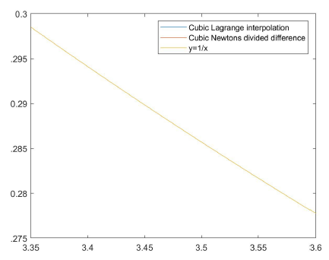

# **Problem: 5**

♦ **Statement:**

With the data in provided in table

1. Interpolate successive points by straight line segments. This is known as piecewise linear interpolation .

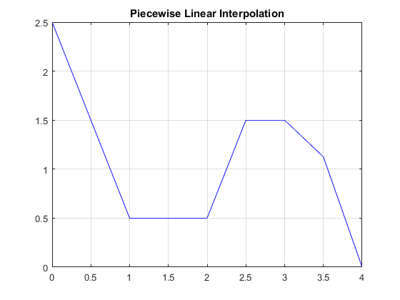

1. On each of the three following subintervals of x [0 2] , [2 3] and [3 4] interpolate using both lagrange's quadratic polynomial and Newton’s divided-difference interpolation polynomial .

* For x[0 2] :-

Lagrange Quadratic Interpolation

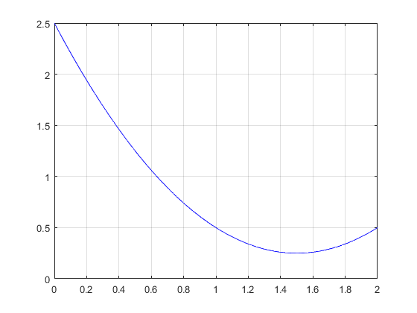

Newton’s divided-difference interpolation



* For x[2 3] :-

Lagrange Quadratic Interpolation

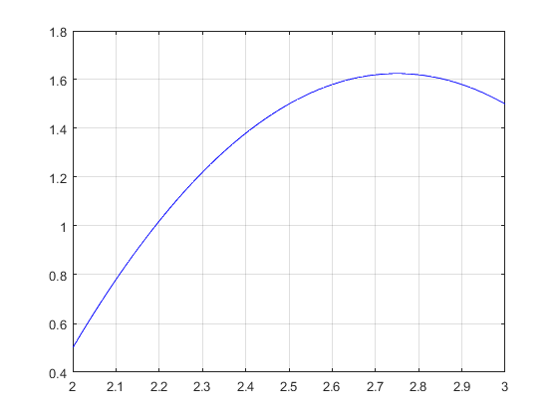

Newton’s divided-difference interpolation



* For x[3 4] :-

Lagrange Quadratic Interpolation

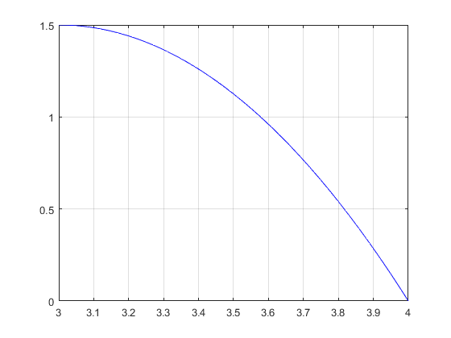

Newton’s divided-difference interpolation



1. Plot the results of both methods Covering all the three subintervals on the same graph and compare them

